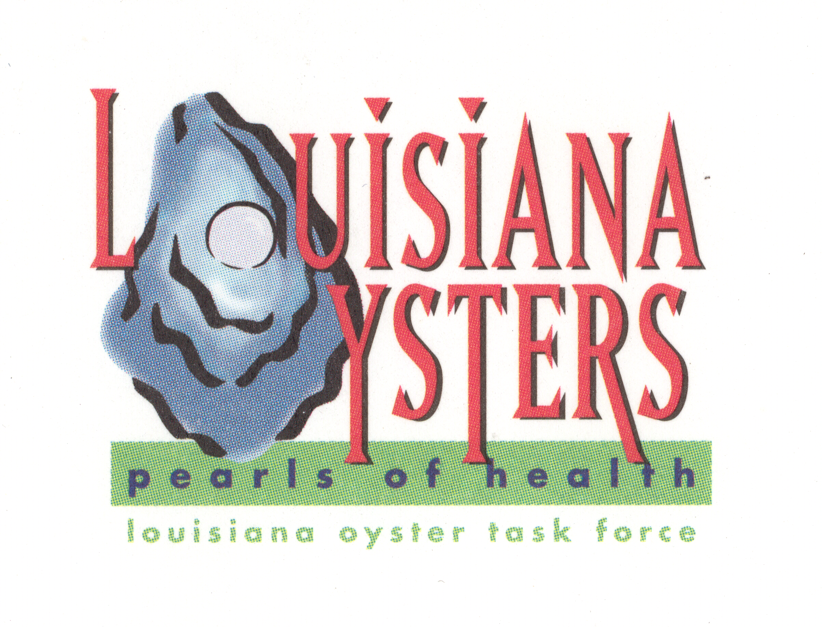

Louisiana Oyster Task Force Meeting
John Tesvich, Chairman

Tuesday August 23, 2011 1:00 PM
UNO Advanced Technology Center, 2021 Lakeshore Drive, Suite 210
Minutes

- Roll Call
Present: Shane Bagala, Patrick Banks, Glenn Cambre, Wilbert Collins, Dan Coulon, Byron Encalade, Jakov Jurisic, Steve McManus in for Major Sammy Martin, Ralph “Buddy” Pausina, Brad Robin, Al Sunseri, John Tesvich, Sam Slavich, Mike Voisin
Absent: Dana Brocato, David Deere, Karl Morgan, Peter Vujnovich, Jerome Zeringue
- Approval of May 10, 2011 MINUTES, Approval of August 3, 2011 MINUTES
Motion to approve May 10 minutes by Wilbert Collins, second by Dan Coulon
Motion to approve Aug 3, 2011, motion by Dan Coulon, second by Wilbert Collins
- Treasury Report
A. Oyster Tag Sales-692,154 tags sold in fiscal year 2010-2011, prior was over $2 million, 2, 983,944
B. LOTF Budget – Motion by Buddy Pausina to request more detailed budget (showing dollars from last year at first meeting of fiscal year). Jakov Jurisic moves to have this detailed budget presented semi annually. Second by Dan Coulon. Motion carries.
IV. Committee Reports
Motion to add Ewell Smith to the agenda and move Joey Shephard from New Business. Motion by Mike Voisin, second by Wilbert Collins. Public given the opportunity to comment. No comments heard. Motion carries.
Ewell Smith presented the seafood board’s strategic marketing plan.
Joey Shephard presented the LDWF “Wild Caught” Louisiana shrimp certification program.
Mike Voisin made a motion that the Oyster Task Force support the concept of the certification program as presented to include oysters, Al Sunseri seconds the motion. Motion carries.

- Public and Private Oyster Grounds Committee –
Buddy Pausina asked Mark Schexnyder to report. CPRA has finished assessment of pending applications and sent those to LDWF. They have been working through the applications and will be going before the commission. There are 488 total pending leases, submitted prior to 2002. Of those 188 are clear of issues. They are still getting clarification on dual claim leases.
B. Enforcement - Steve McManus reported. FDA is currently evaluating WLF patrol frequencies there are also going to be monitoring refrigeration on boats.

C. Legislative - Mike Voisin spoke on the bill relating to lifting the moratorium, creating opportunity for substitute leases in public areas. The task force has been asked to provide comment. The bill will be sent out to all task force members. A member of the audience ask that we consider the timing of the session and how this bill might affect the pending damage claims. John Tesvich ask that the task force submit comments and get with attorney Phil Cossich to hear his concerns about the timing of the bill.

Research – Two reports, one from Dr. Soniat and one from Dr. Supan. Dr. Supan reported several samples with no seed oysters. Level of dermo in 3 mile pass was relatively high.
Research committee discussed two items at their committee meeting, one is a research report on the comprehensive historical report of the public seed grounds east of the Mississippi river. John Tesvich asked that the task force discuss the research report and develop an RFP, motion by Dan Coulon, second by Jakov Jurisic. John Supan said that the committee will draft the RFP and present it to the board for edits. Motion carries.
Second item was to ask for a research project to study the occurrence of fouling organism and the idea to remediate it. Causes silt. Could be a sponge that is catching the silt and affecting the spat sat. Motion by Mike Voisin to draft and RFP for the research to see what the fouling organism is. Second by Wilbert Collins. Motion carries.

E. Coastal Restoration – (Dan Coulon)

Al made a motion that the task force writes a letter to Garrett Graves stating that the Oyster industry have representatives at the table for the state’s master plan and encourage the shrimp task force and crab task force to do the same. Wilbert Collins seconds the motion. Motion Carries. Jakov asked that we communicate or write a letter to the other task forces asking them to do the same. Motion carries. Ashley will send out the documents that Dan Coulon presented at the meeting.

F. Marketing – No report

G. Health – (Glenn Cambre)

V. Old Business
    - BP Oil Spill Remediation
      - Claims Process- Buddy Pausina talked about the final rules regarding the claims process and noted that it recognizes the losses due to fresh water diversion. It is available on the GCCF Web site.
      - Public Reef Remediation- Sam Slavich made a motion that the task force sponsor and submit suggested program to NERDA for rehabilitating a project on both the public and private ground, using oyster harvest vessels to cultivate water bottoms. Second by Brad Robin. Motion carries.

      - Oyster Lease Remediation
    - Oyster Lease Moratorium Update
    - Sabine Lake Oyster Reefs Update
    - Public Oyster Reef Evaluation & Shell Plants – Patrick Banks
VI. New Business
- 2011 – 2012 Public Seed Ground Season Recommendations
Patrick Banks presented the recommendations for the 2011-12 Public Seed Ground Season Recommendations
CSA1 (Black Bay area)- November 14-Dec 31 season. Sacking only 30 sack limit.
CSA 3- Little lake public seed ground. September 7-April 1, 2012
CSA 5- East Lake Chien, Lake Felicity- October 26-28, 2011
CSA 5 West-Sister Lake Public Oyster Seed Preservation- October 26-November 25, 2011. Sacking only-50 sack limit.
Lake Mechant public seed ground, October 26-28, 2011.
CSA VI- Vermillion/Cote Blanche/Atchafalaya Bay-Same as CSA 3 (Little Lake) Fall season, Sept 7-Aril 1, 2012.
CSA VII- Calcasieu Lake-West Cove- November 1, 2011-April 30, 2012, 10 sack limit.
No season in CSA 1North, CSA 1South (except for as above), Hackberry Bay, Barataria Bay, Deep Lake, Lake Tambour, Bay Junop, Calcasieu Lake (east), Sabine Lake.

Al Sunseri made a motion that Hackberry Bay, Barataria Bay, Little Lake, Sister Lake shell plant open for bedding only as proposed under the law, the first Wednesday after Labor Day through October 1.
CSA 1 North-CSA 6 open October 15-April 1 for sacking. Open for everything January 1- April 1.
Calcasieu Lake west cove opened as listed and east cove opened November 20- April 1. 10 sack limit.
Sabine Lake open October, March, April and May. 10 sack limit.
Wilbert Collins seconds.
Mike Voisin made a substitute motion that the original season recommendations as contained in the Oyster Task Force season recommendations be brought to wildlife and fisheries department, commission chair and a committee of oyster task force members with chairman prior to the commission meeting. And that the committee be authorized to speak on behalf of the task force after their deliberations. Al Sunseri seconds the motion. Motion carries, two opposed Dan Coulon and Jakov Jursic.
- Interstate Shellfish Sanitation Conference/proposal list – DHH and Al Sunseri
Motion by Wilbert Collins to adopt all positions outlined in the ISSC document with the exception of 11-203, should go from monitor to for. Second by Mike Voisin. Motion carries.
- LOTF sponsored ISSC Hospitality room (Al Sunseri)- Motion by Al Sunseri to go in on sponsorship for the hospitality room for $5,000 at ISSC. Second by Mike Voisin. Motion carries.
Mike made a motion the task force fund the travel for Bobby Savoie and Jakov Jurisic. Also traveling will be Wilbert Collins, Al Sunseri, Mike Voisin and John Tesvich.
Second by Wilbert Collins. Motion carries.
- Set Next Meeting- November 1, 1 p.m.
- Adjourn- motion to adjourn by Al Sunseri, second by Jakov Jurisic. Motion carries

